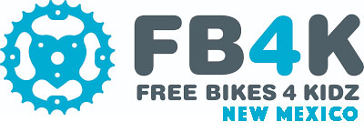
Executive Director Position
Free Bikes 4 Kidz is a non-profit organization committed to collecting and repairing used bikes on a large scale. Partner groups then place the refurbished bikes with disadvantaged children and adults across the state. The result is healthier, happier kids – away from the screens.
Responsibilities

- Recruit, train and lead staff and volunteer activities
- Coordinate with partnering organizations for bike distribution
- Engage with sponsors, bike shops, media, and influencers
- Systematically track progress, measure successes, and ensure excellence
- Develop and execute strategic plans, marketing initiatives, and budgets

Qualifications
- Commitment to Free Bikes 4 Kidz mission and growing the organization
- Excellent communication skills; able to lead, develop and motivate others
- Confidence with public relations, government negotiation, and fundraising
- Ability to oversee a wide variety of projects simultaneously, meet deadlines
- Valid driver’s license; able travel to collection and repair sites

